# Excersises - Introdusing Symfony

This document defines a set of tasks to be done as a part of the MVC Introduction lecture’s exercises.

[Model-View-Controller](https://en.wikipedia.org/wiki/Model%2525E2%252580%252593view%2525E2%252580%252593controller) architectural design pattern is one of the most used patterns in the architectural toolset chosen for web applications in the past 5 years.

# Install Symfony Installer and Composer

## Symfony Installer

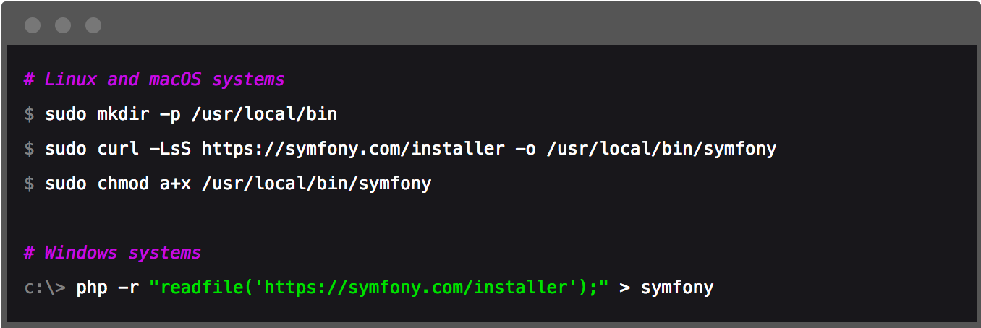Excecute following commands depending on your OS

For **Linux and macOS** -a global **symfony** command is created.

For **Windows** - **move** **symfony** into directory included in your **PATH** environment.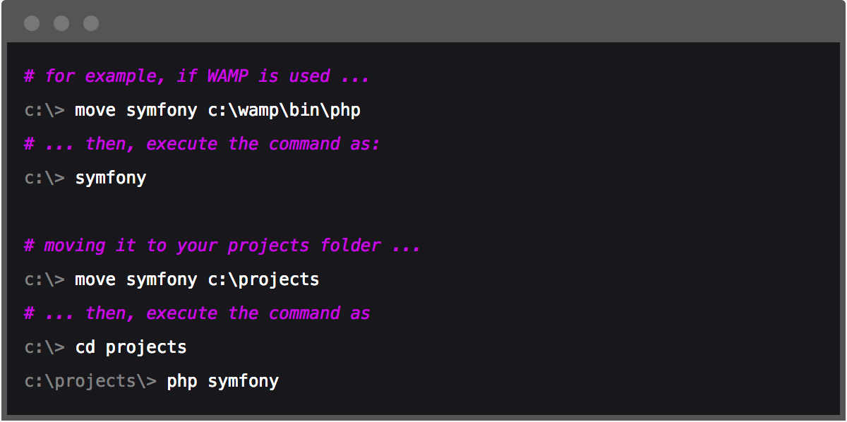

## 2. Install Composer

**Composer is command line tool, a dependency manager for PHP.**

**All packages i**nstalled by Composer **are installed per-project, not globally.**

When installing package **composer** will **automatically add/include** the package **to our application.**

**Install composer** - go to <https://getcomposer.org/download/> and follow instructions.

You should get similar result: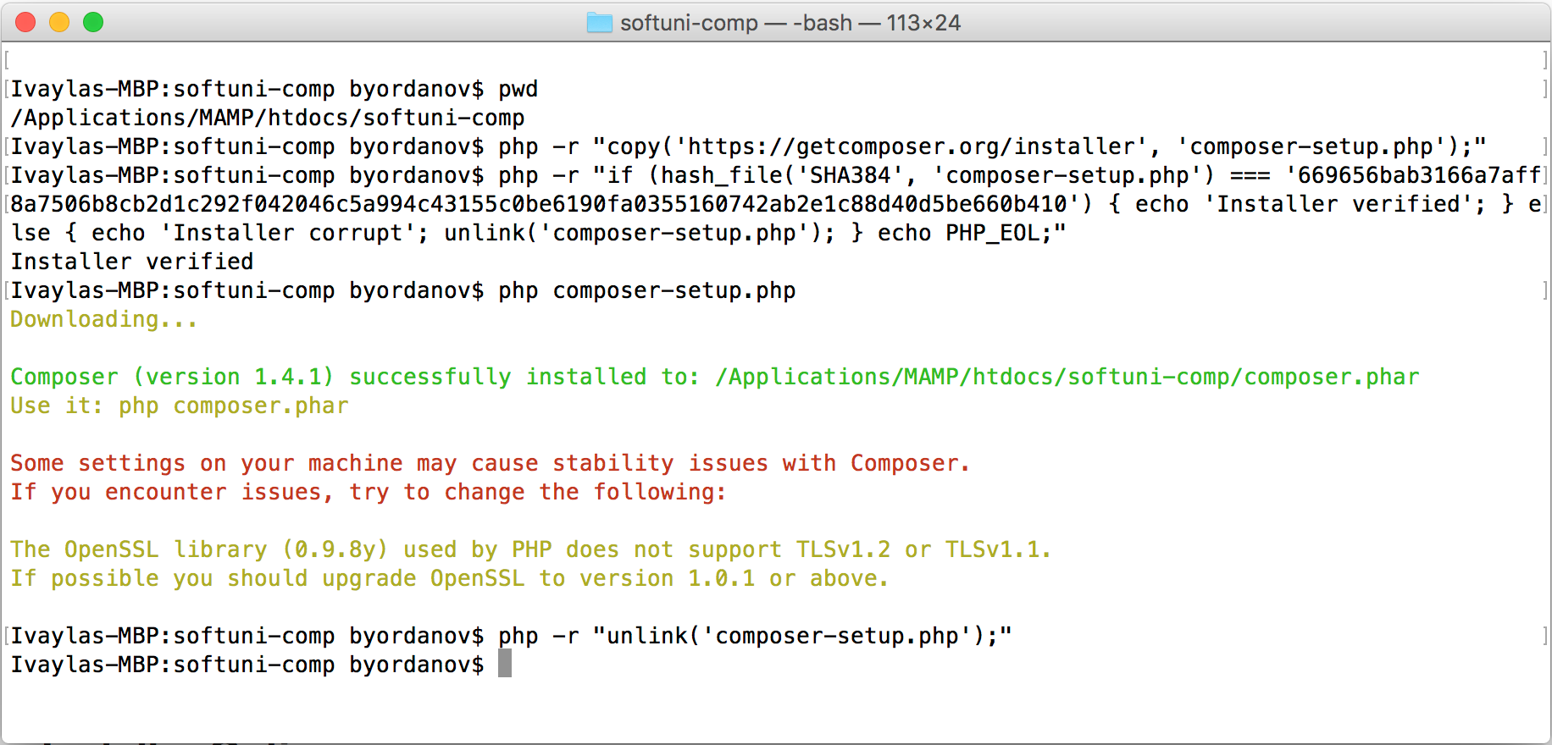

# Install Symfony

## Install with Symfony Installer

Navigate to the root directory of your server.

Choose a name for your project.

Execute following command:

**After successful installation of Symfony you should get similar result:**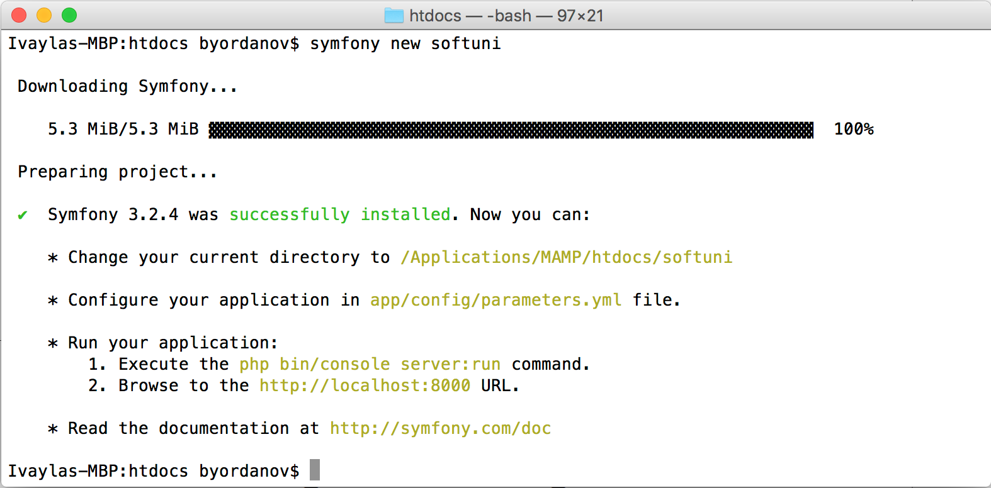

**You can install specific version if needed:**

**Experiment** with installing different versions.

## Install with Composer

Navigate to the root directory of your server.

Choose a name for your project.

Execute following command: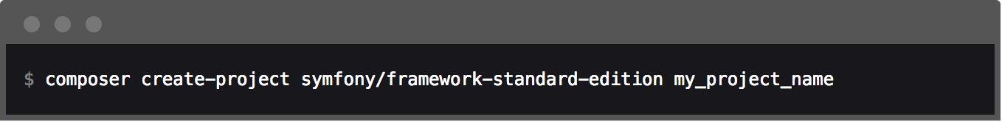

The command will create a new directory **my_project_name.**

Install specific version of Symfony Framework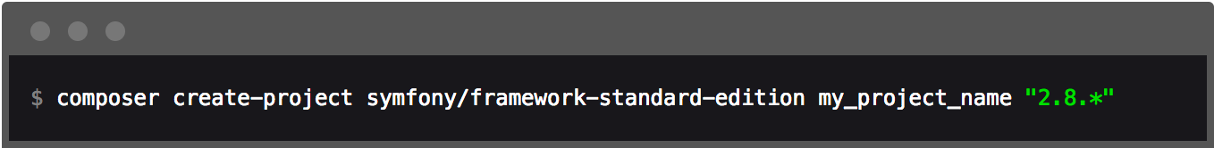

**Attention: If you installed Composer locally** for your project **use composer.phar instead of composer** in the above command.

# Run Symfony

**First thing to do**: check if our server is ready to run Symfony.

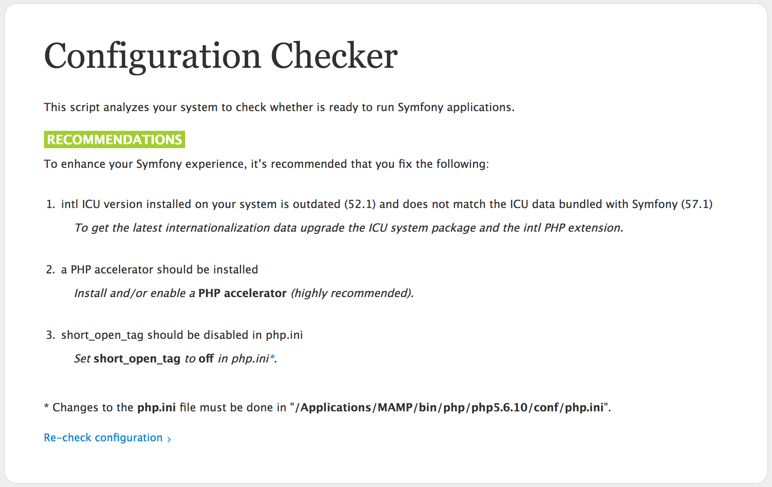

If you see **warning messages** change your server configuration appropriately.

Once you don’t see warning messages go to next step:

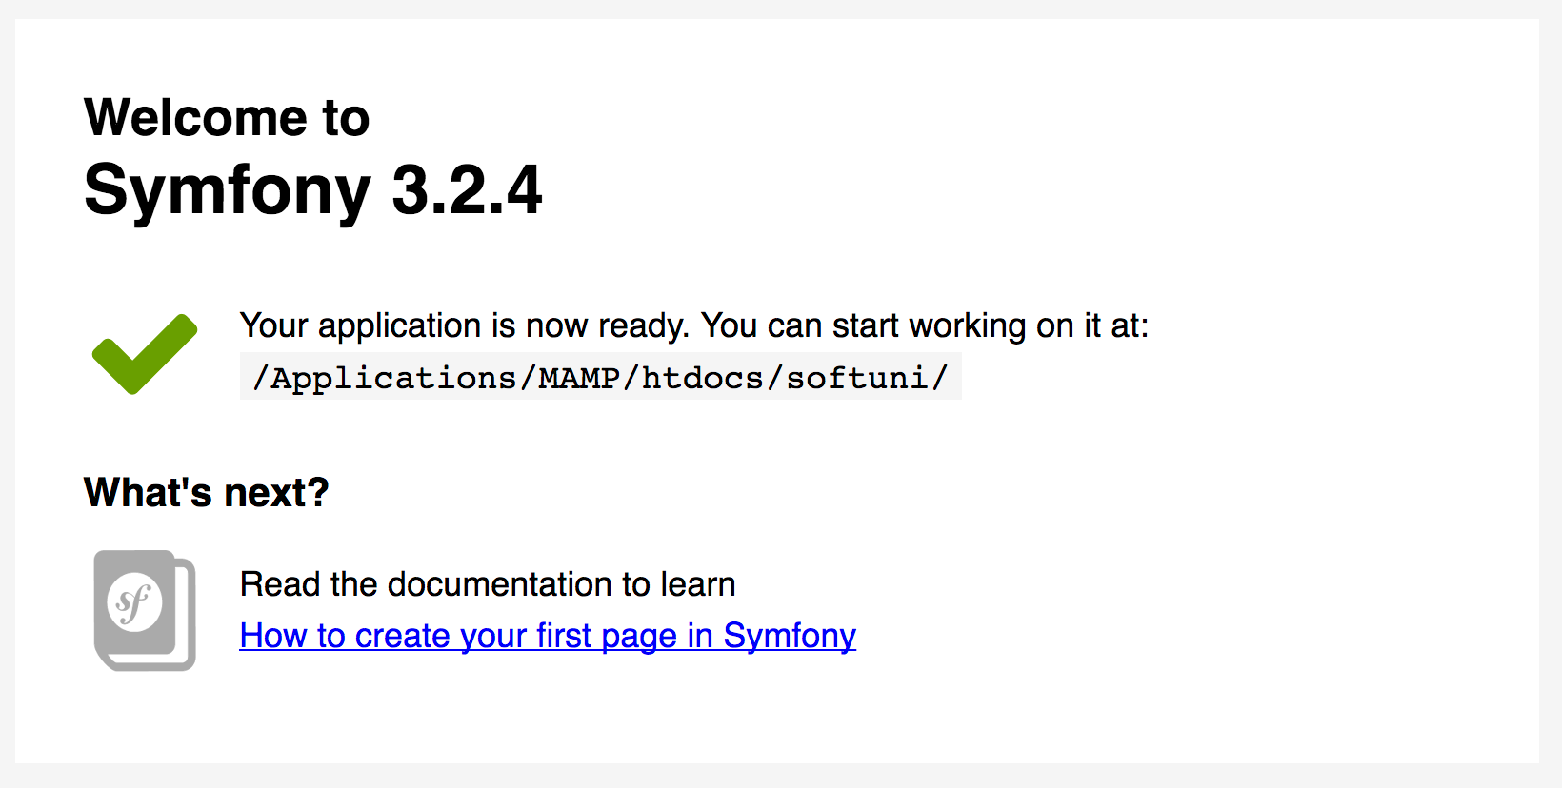

# Congratulations! You’ve installed Symfony!

## Create your first project

**Got to web root directory** of your server and execute following command:

This will create a **Symfony Demo project** for you.

Go to project directory.

Check configuration files in **app/** and **app/config/**

Check **src/** directory.

**Find controllers** and play with them.